**Best Tips on What Apparel Color Goes With Brown**

Brown is a bold and fashionable color. It matches with almost any color, and this means that you can never go wrong with brown. From brown shoes, pants, to brown outerwear, the color will give you an elegant look.

Some fashion critics argue that brown never goes with black, but the fact is, fashion never stops. Pair brown with any casual or formal combination, and you will indeed love the look.

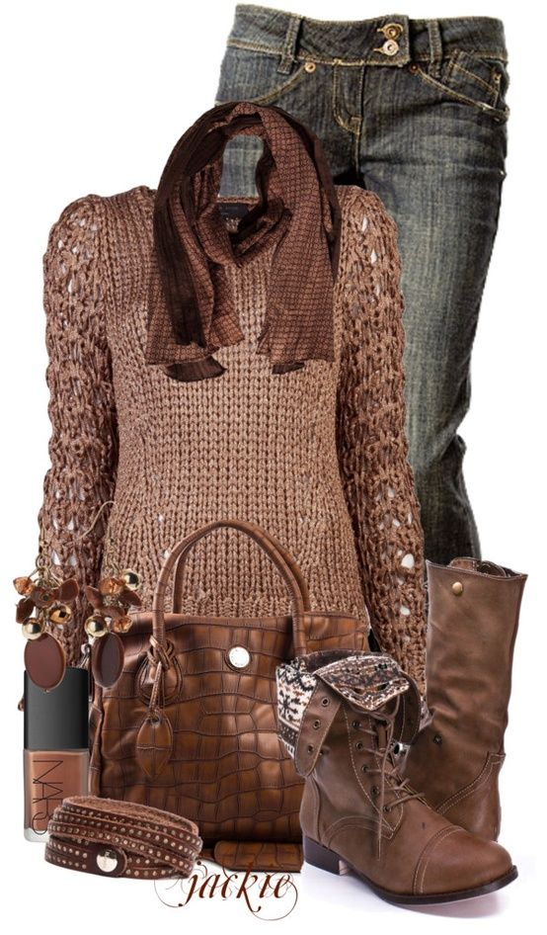

**Brown with Brown**

Of course brown will go with brown any time. Try pairing your brown outfits with other shades of brown from your wardrobe. This works well in all seasons, and the look will be stylish and cool.

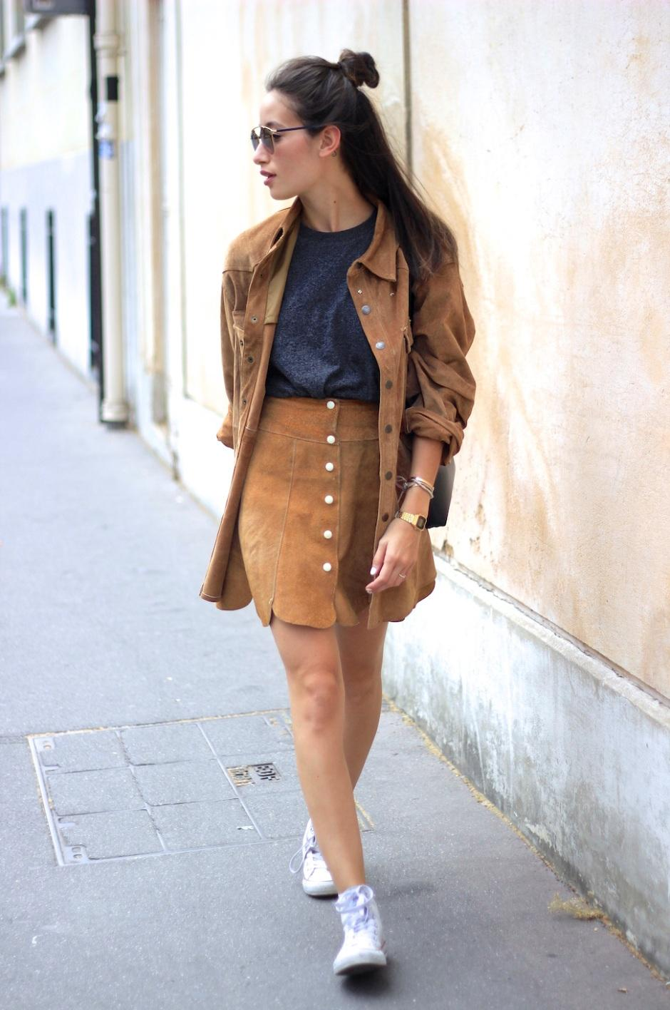

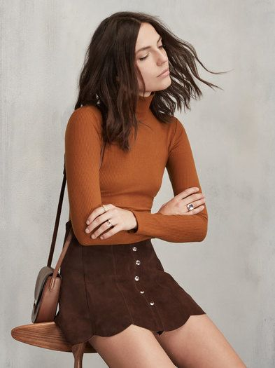

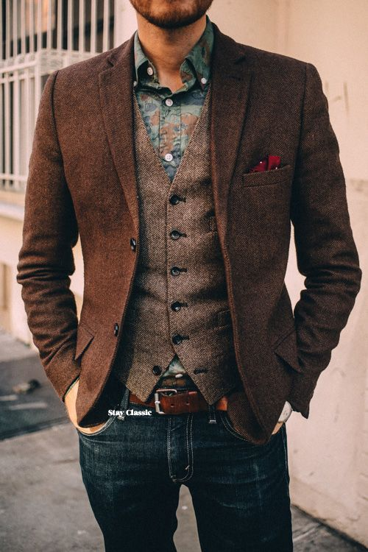

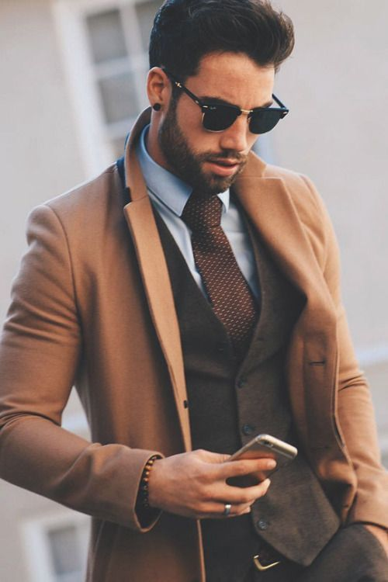

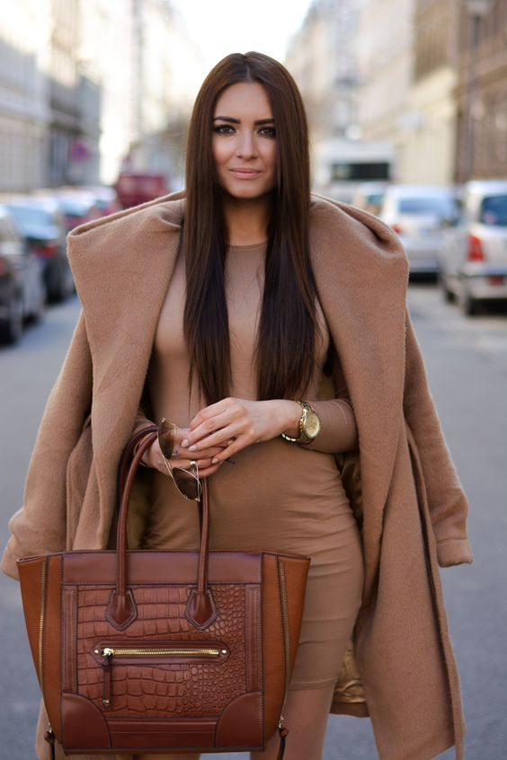

**Brown with Cream**

Cream outfits go well with brown. The combination of a brown outerwear with cream-colored base will never be out of style.

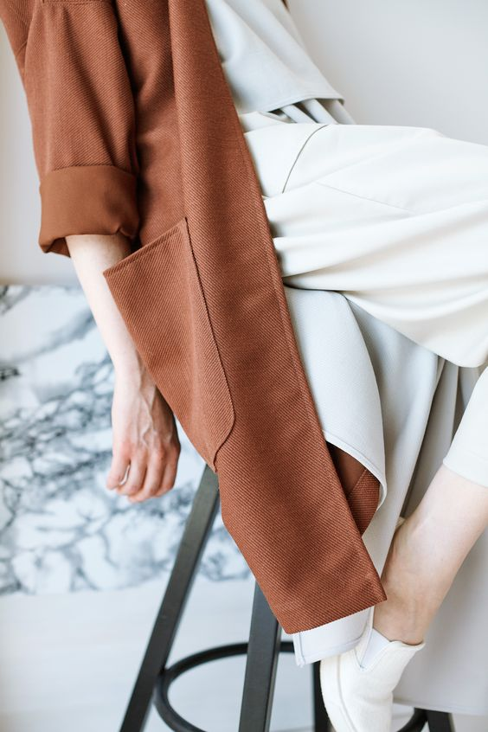

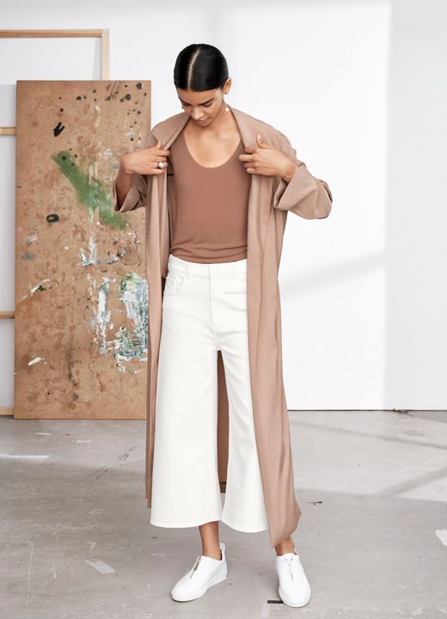

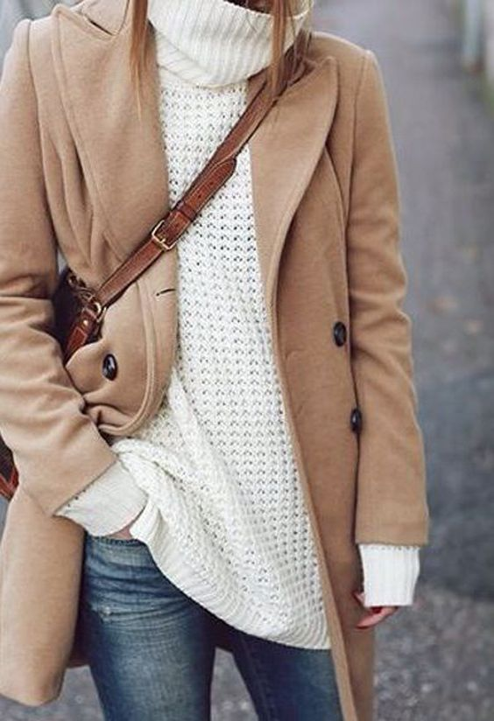

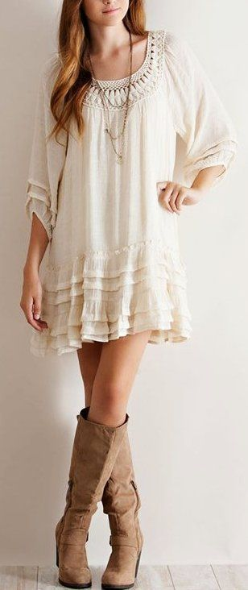

**Brown with maroon or red**

Maroon will never go wrong with brown. The trick is to look for the best hue of red to pair it with brown outfits. Think of a light brown skirt paired with a red top that is not loud.

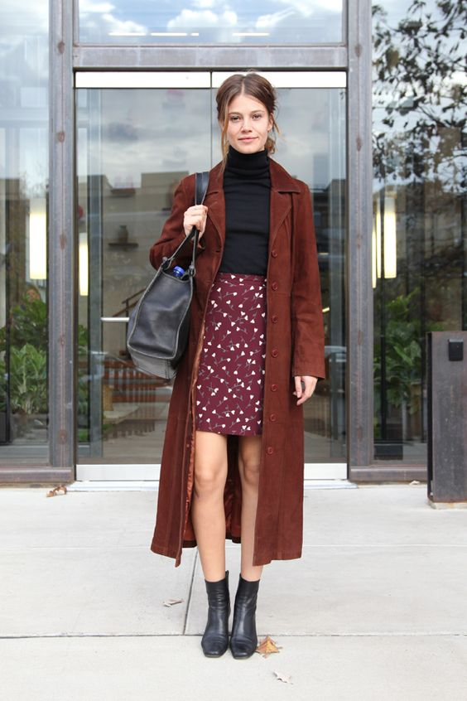

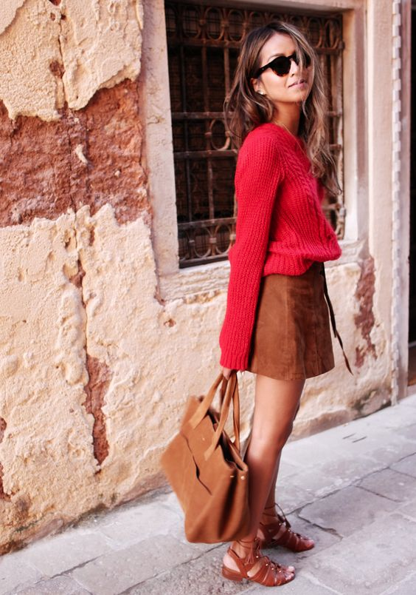

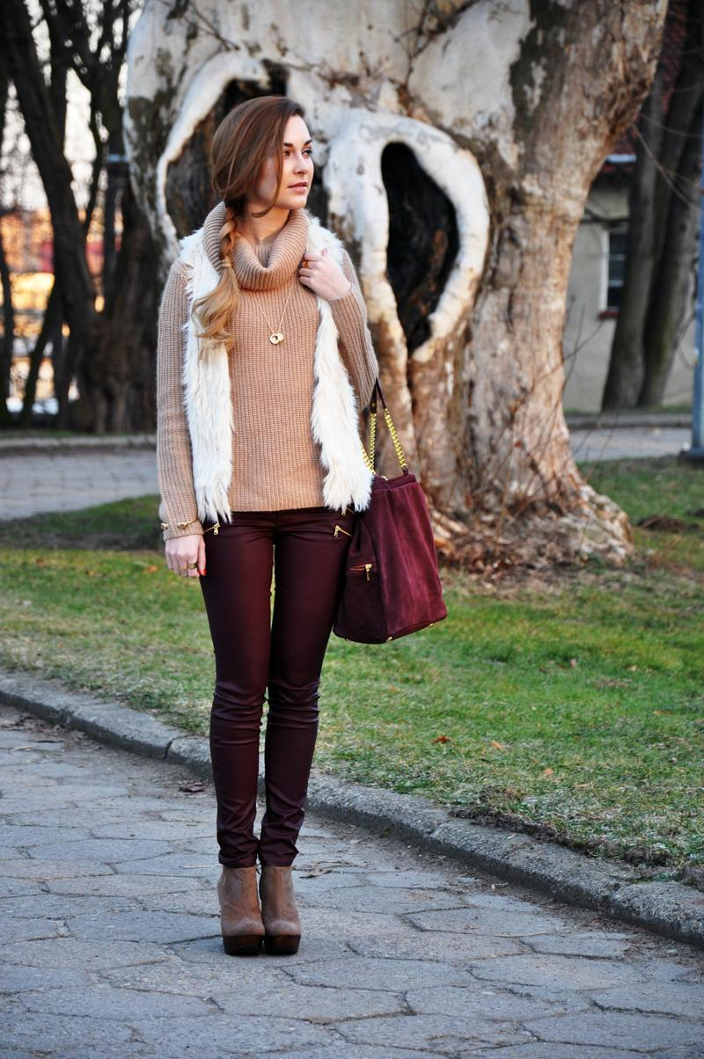

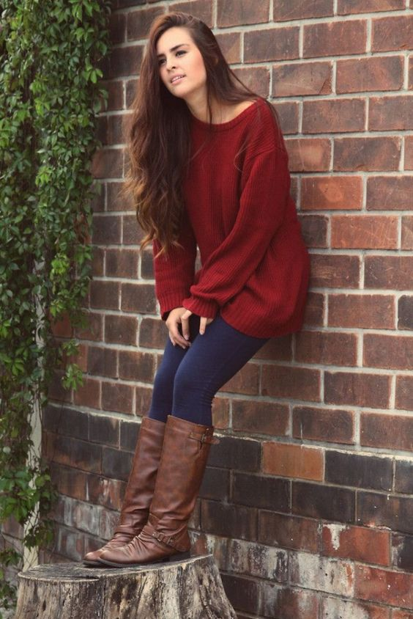

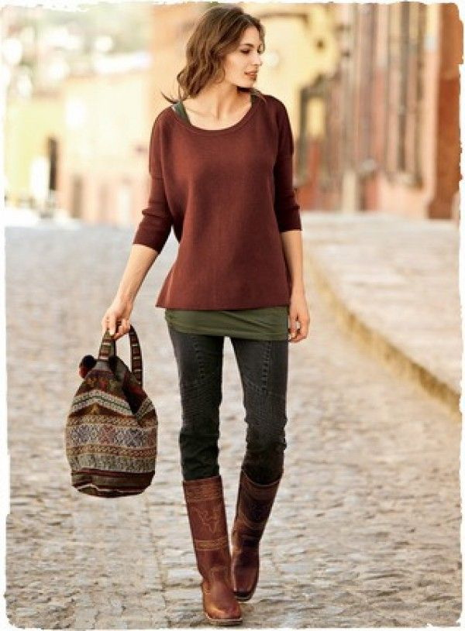

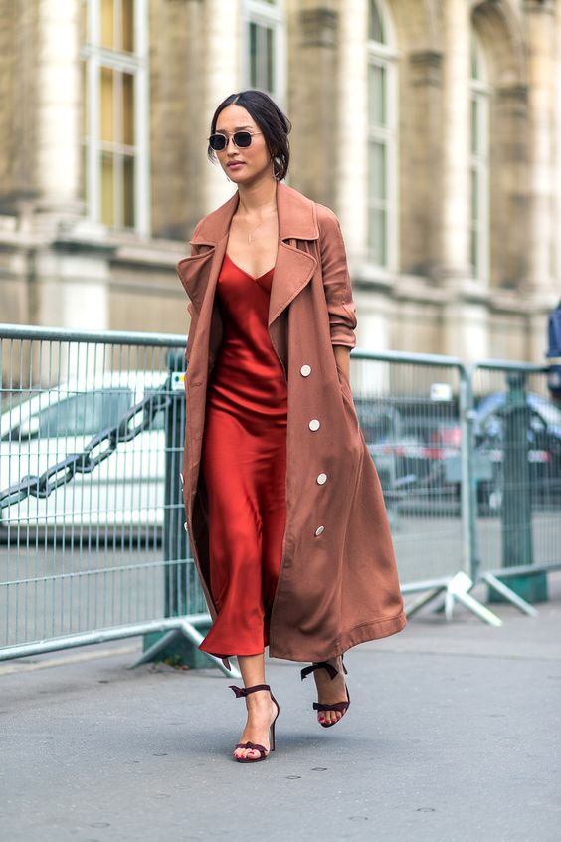

**Brown with Blue**

Navy blue works very well with brown. The result is a classic look that works well especially for men. Men can dress in navy blue jeans and brown boots. Ladies can also go for brown flats and a blue floral dress for that excellent look.

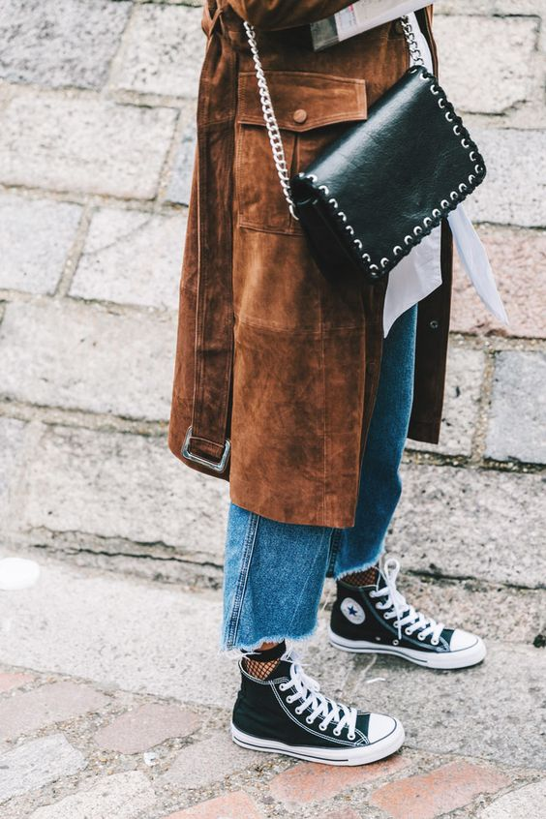

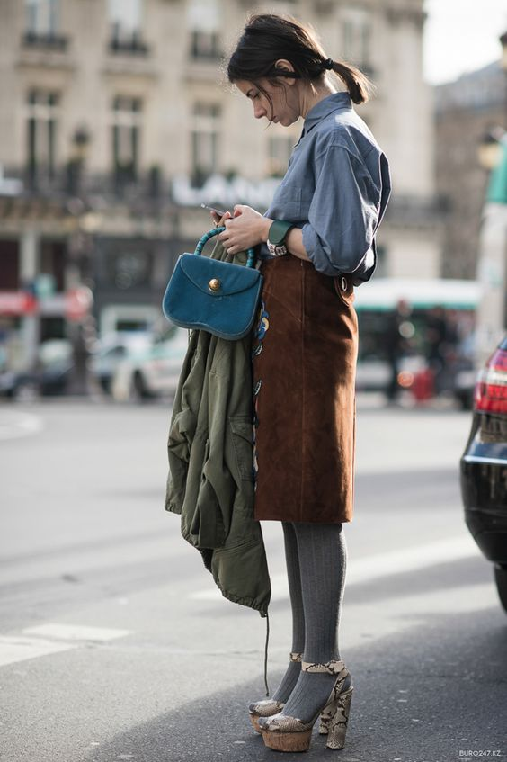

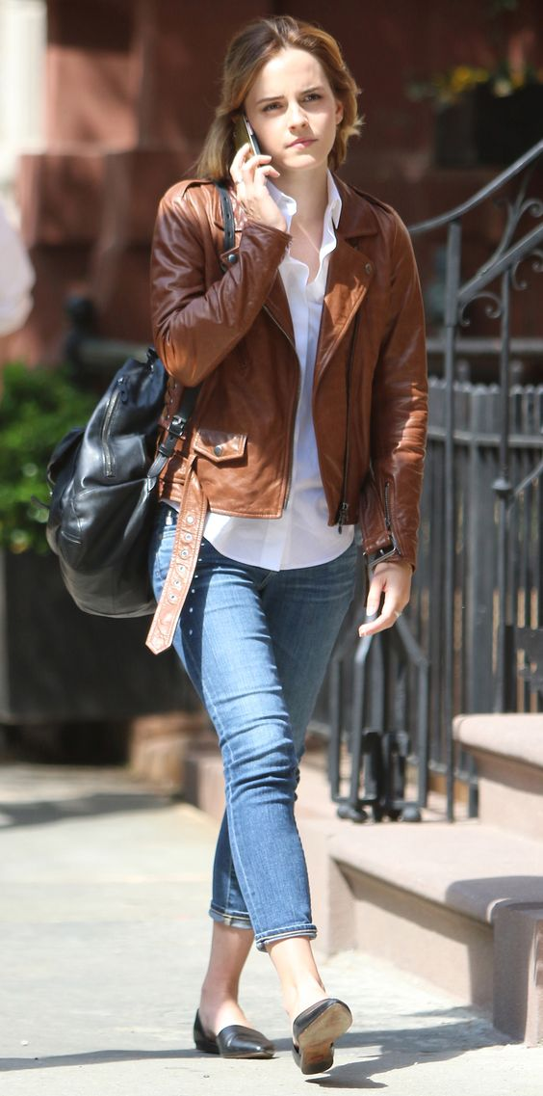

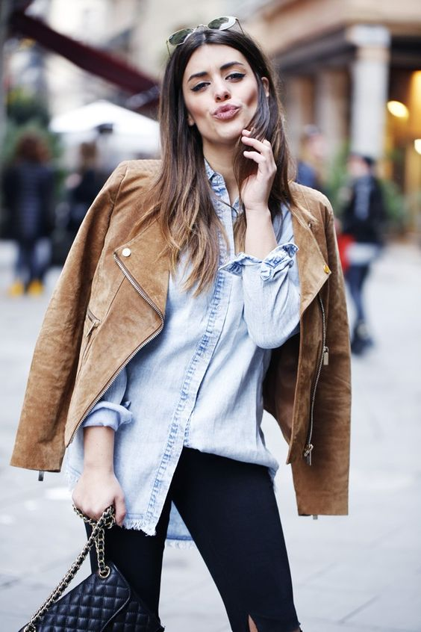

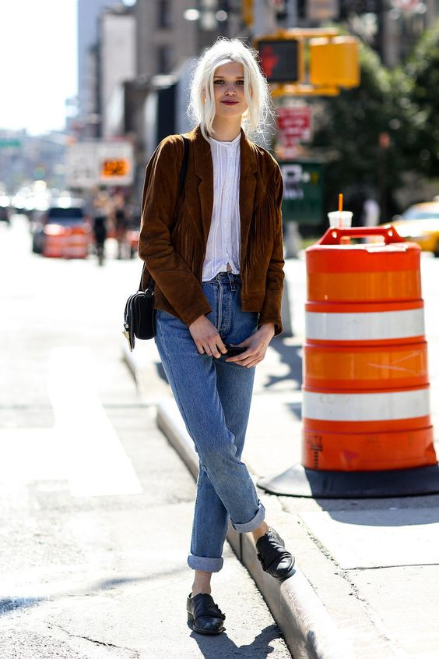

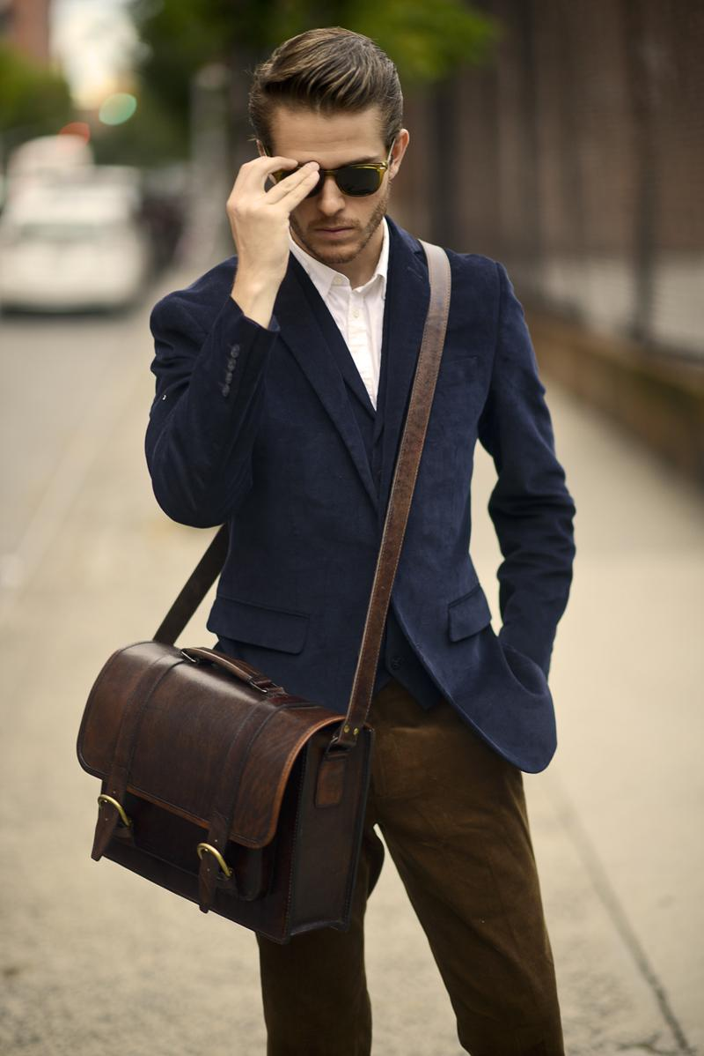

**Brown with Green**

Jungle green is especially very compatible with brown. Green works well with brown and you just have to get the right hue of brown to complete the look. Teal is a hue of green that also goes well with brown, especially light brown.

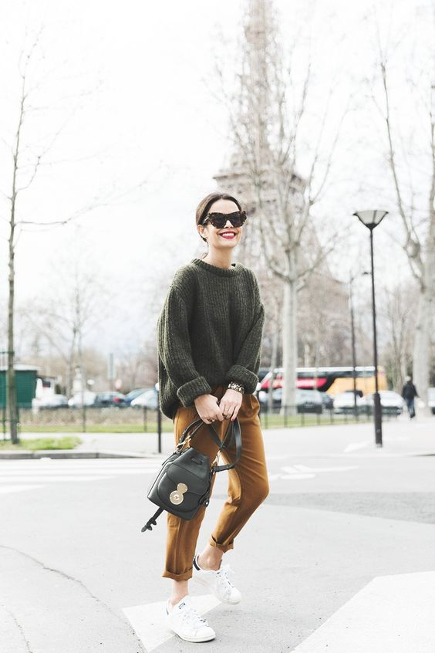

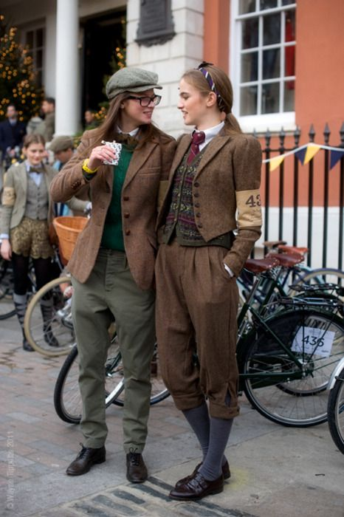

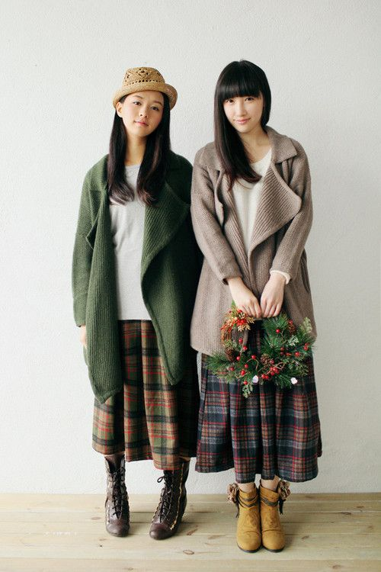

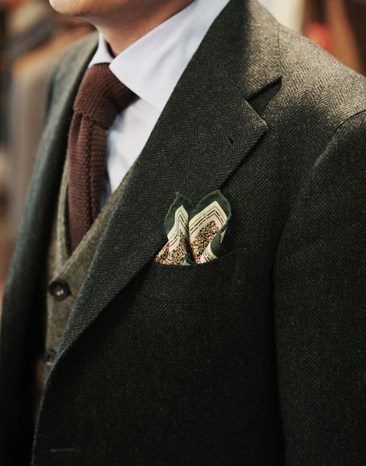

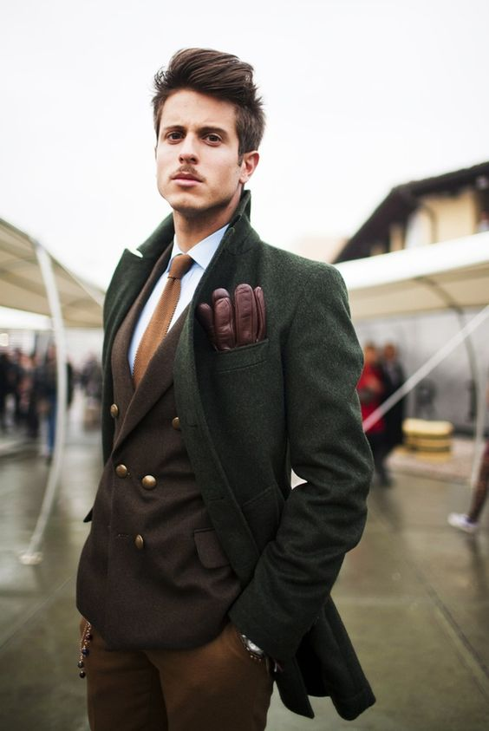

**Brown with Orange**

Orange works very well with brown. From pumpkin orange to pastel orange, this color will blend perfectly with brown outfits, and you will be thrilled.

